Tableau Data Prep and the Importance of Data Visualisation

Working with Tableau Data Prep
Dataset used: CMS Hospital General Information (local file: Hospital_General_Information.csv). The goal of this flow is to clean the dataset and have the analysis ready.

Step 1:
- I have connected to (Hospital_General_Information.csv) using Tableau Prep Builder (File - New Flow - +Connect), dragged the table to the canvas, and added a Clean step.
- I have the Verified field types in the Profile pane. Then, converted the ZIP Code and Telephone Number to a String.
- Also, kept the group measures columns as String initially because they include the textual placeholder as “Not Available.”
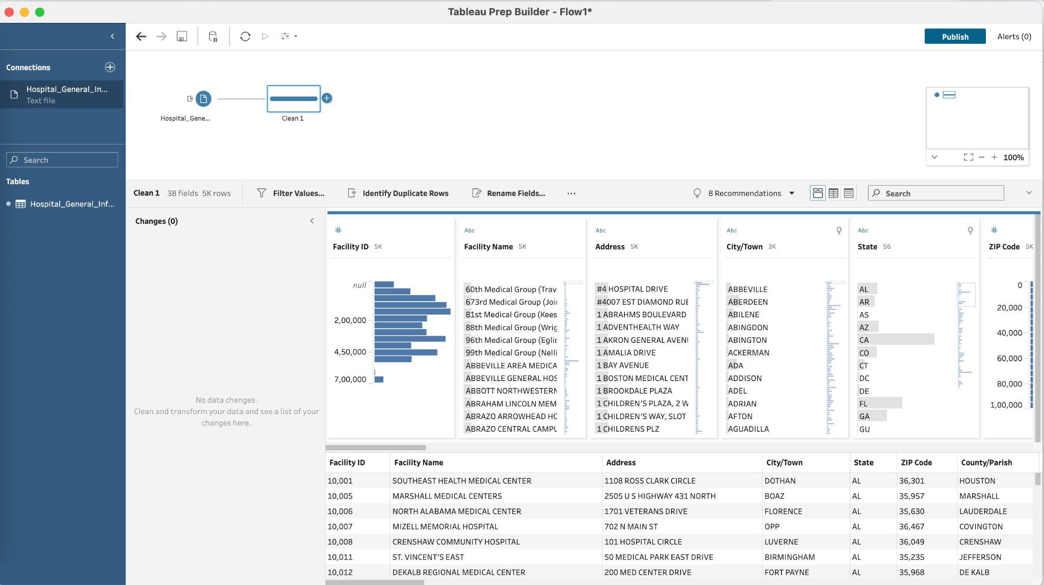

Step 2:
- For readability in downstream dashboards, I thought of renaming City/Town - City and County/Parish - County_Parish
- I have consistent casing and space usage in headers; I have avoided special characters, which show “errors” in calculated fields.
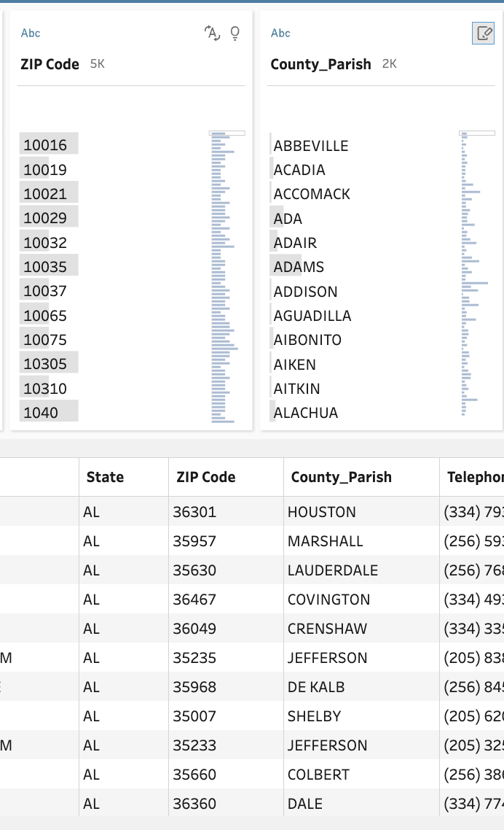

Step 3:
- ZIP (5-digit): created a ZIP5 string to keep leading zeros.
- In Phone standardisation, I have extracted digits and then reformatted them as (XXX) XXX-XXXX for a valid 10-digit number.
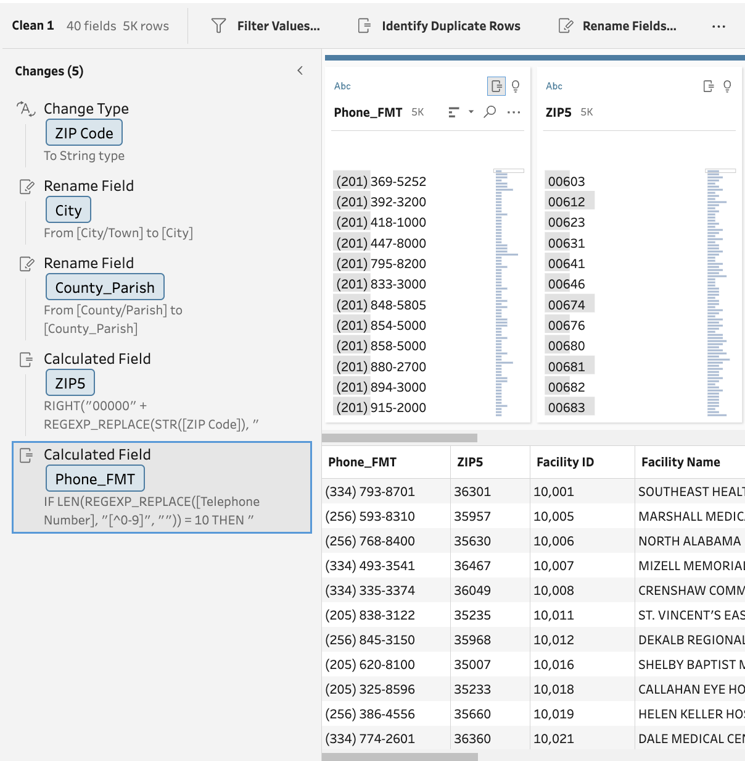

Step 4:
- I have used Group & Replace on Hospital Ownership and Hospital Type to merge case variants if present, for example - (e.g., Government-Local vs Government-Local).
- Also, kept Emergency Services values as Yes/No for traceability.
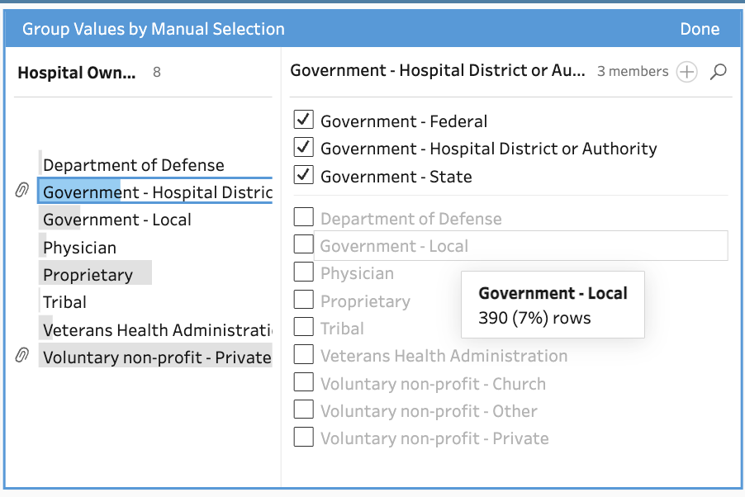

Step 5:
- I have made changes to the labels and created a “Calculated field”
- Overall rating: created Overall_Rating_Int.
- Emergency services flag: Emergency_Services_Flag.
- Birthing designation: Birthing_Friendly.
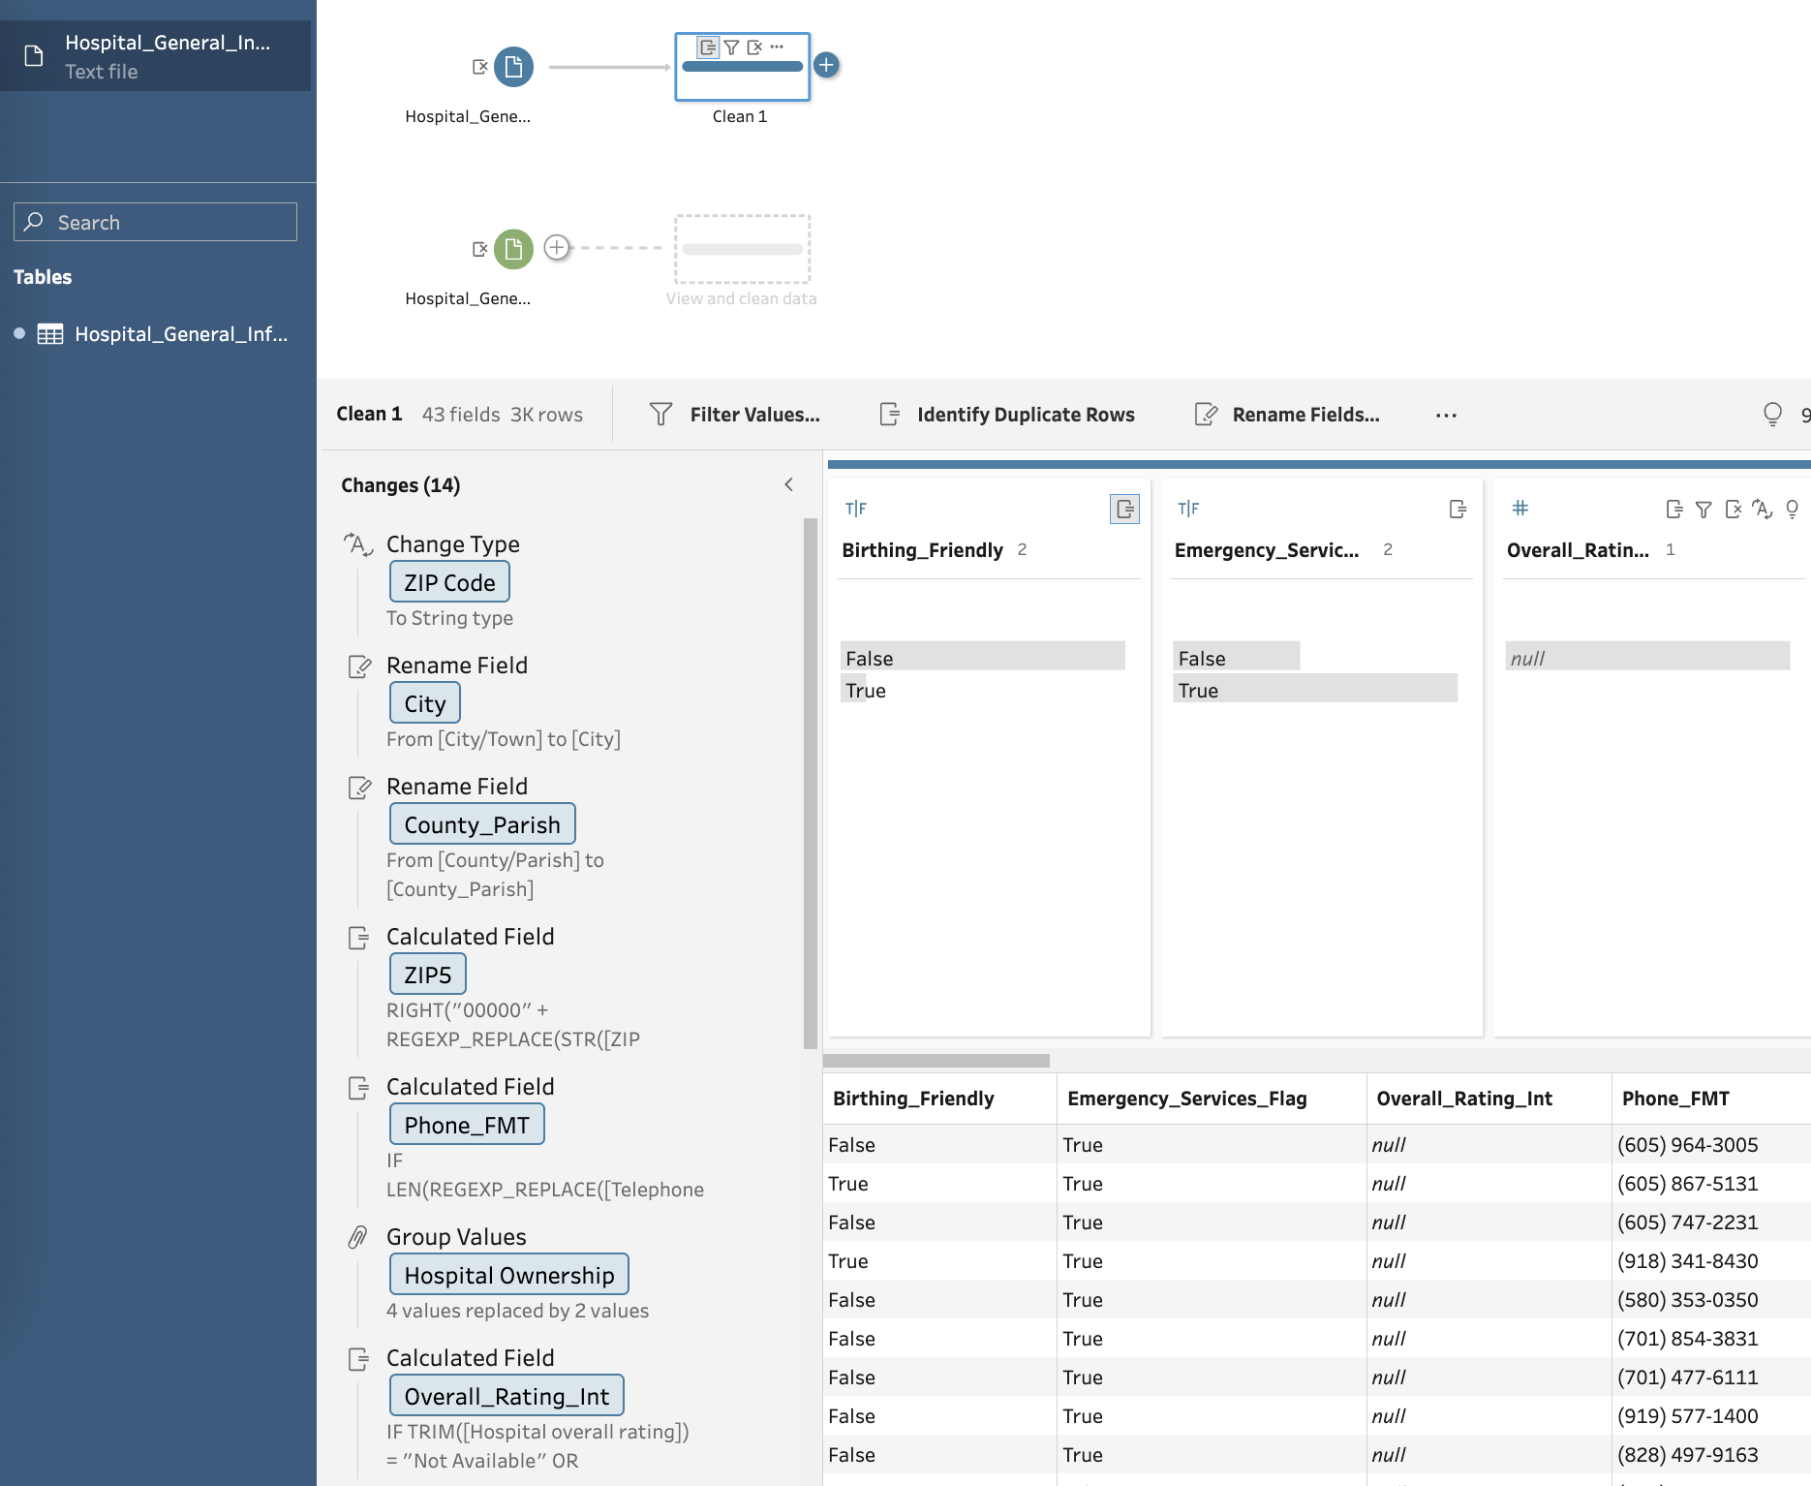

Step 6:
- Created an analysis field for MORT, Safety, READM, Pt Exp, and TE
- Converted each group’s counts from String to Not Available to Integer with Nulls. Example for Mortality:
- For Facility_MORT_Count -
(IF [Count of Facility MORT Measures] = "Not Available" THEN NULL
ELSE INT([Count of Facility MORT Measures]) END)
- Used this code for MORT -
(IF [MORT Group Measure Count] = "Not Available" THEN NULL
ELSE INT([MORT Group Measure Count]) END)

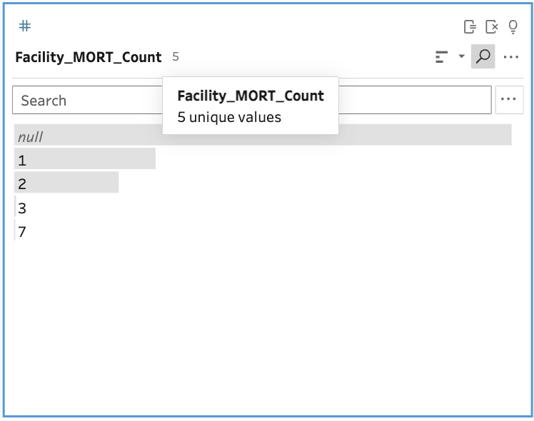

Step 7:
- Started working on the Rating systems using this code (NOT ISNULL([Overall_Rating_Int])
For total measure (ZN([Facility_MORT_Count]) +
ZN([Facility_Safety_Count]) +
ZN([Facility_READM_Count]) +
ZN([Facility_PtExp_Count]) +
ZN([Facility_TE_Count])
- For rating band used (IF [Overall_Rating_Int] IN (1,2) THEN "Low (1–2)"ELSEIF [Overall_Rating_Int] = 3 THEN "Mid (3)"ELSEIF [Overall_Rating_Int] IN (4,5) THEN "High (4–5)" ELSE "Not Rated" END)
- Which helped the right total measures and rating band.
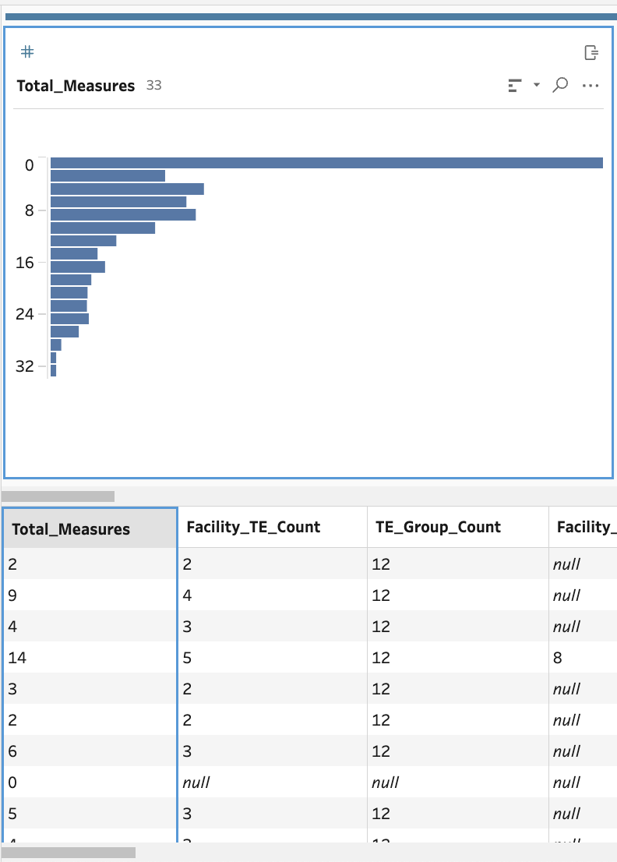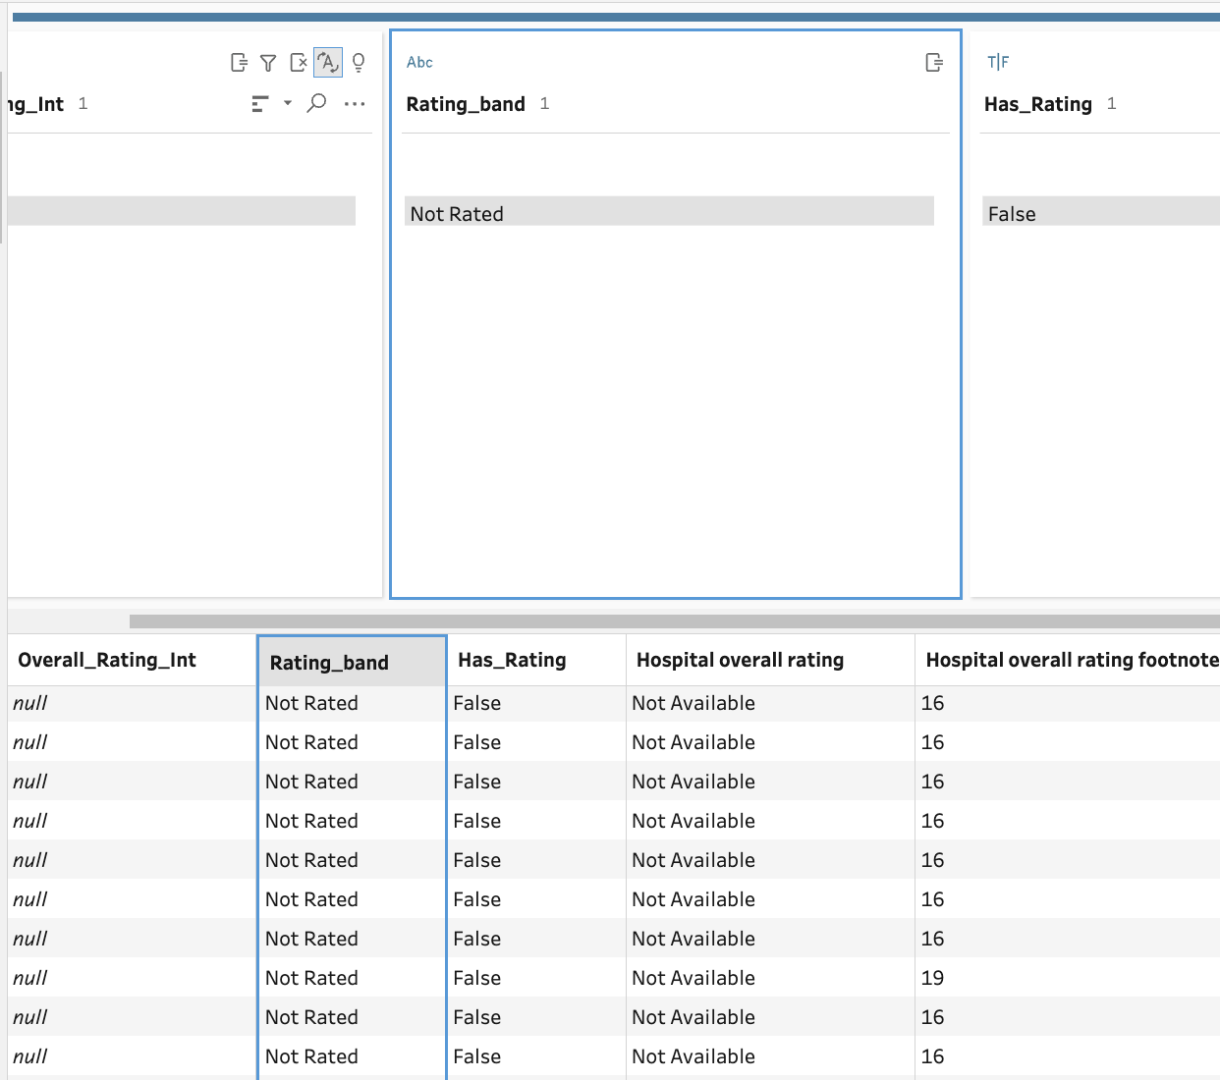

Step 8:
- I have verified that total rows remained constant after non-destructive steps, and the expected count is 5,381.
- Later checked for duplicates - COUNTD(Facility ID) matched row count; no duplicate Facility IDs found.
- Built a quick Aggregate step by State to compare COUNTD (Facility ID), AVG(Overall_Rating_Int), and % Emergency_Services_Flag.

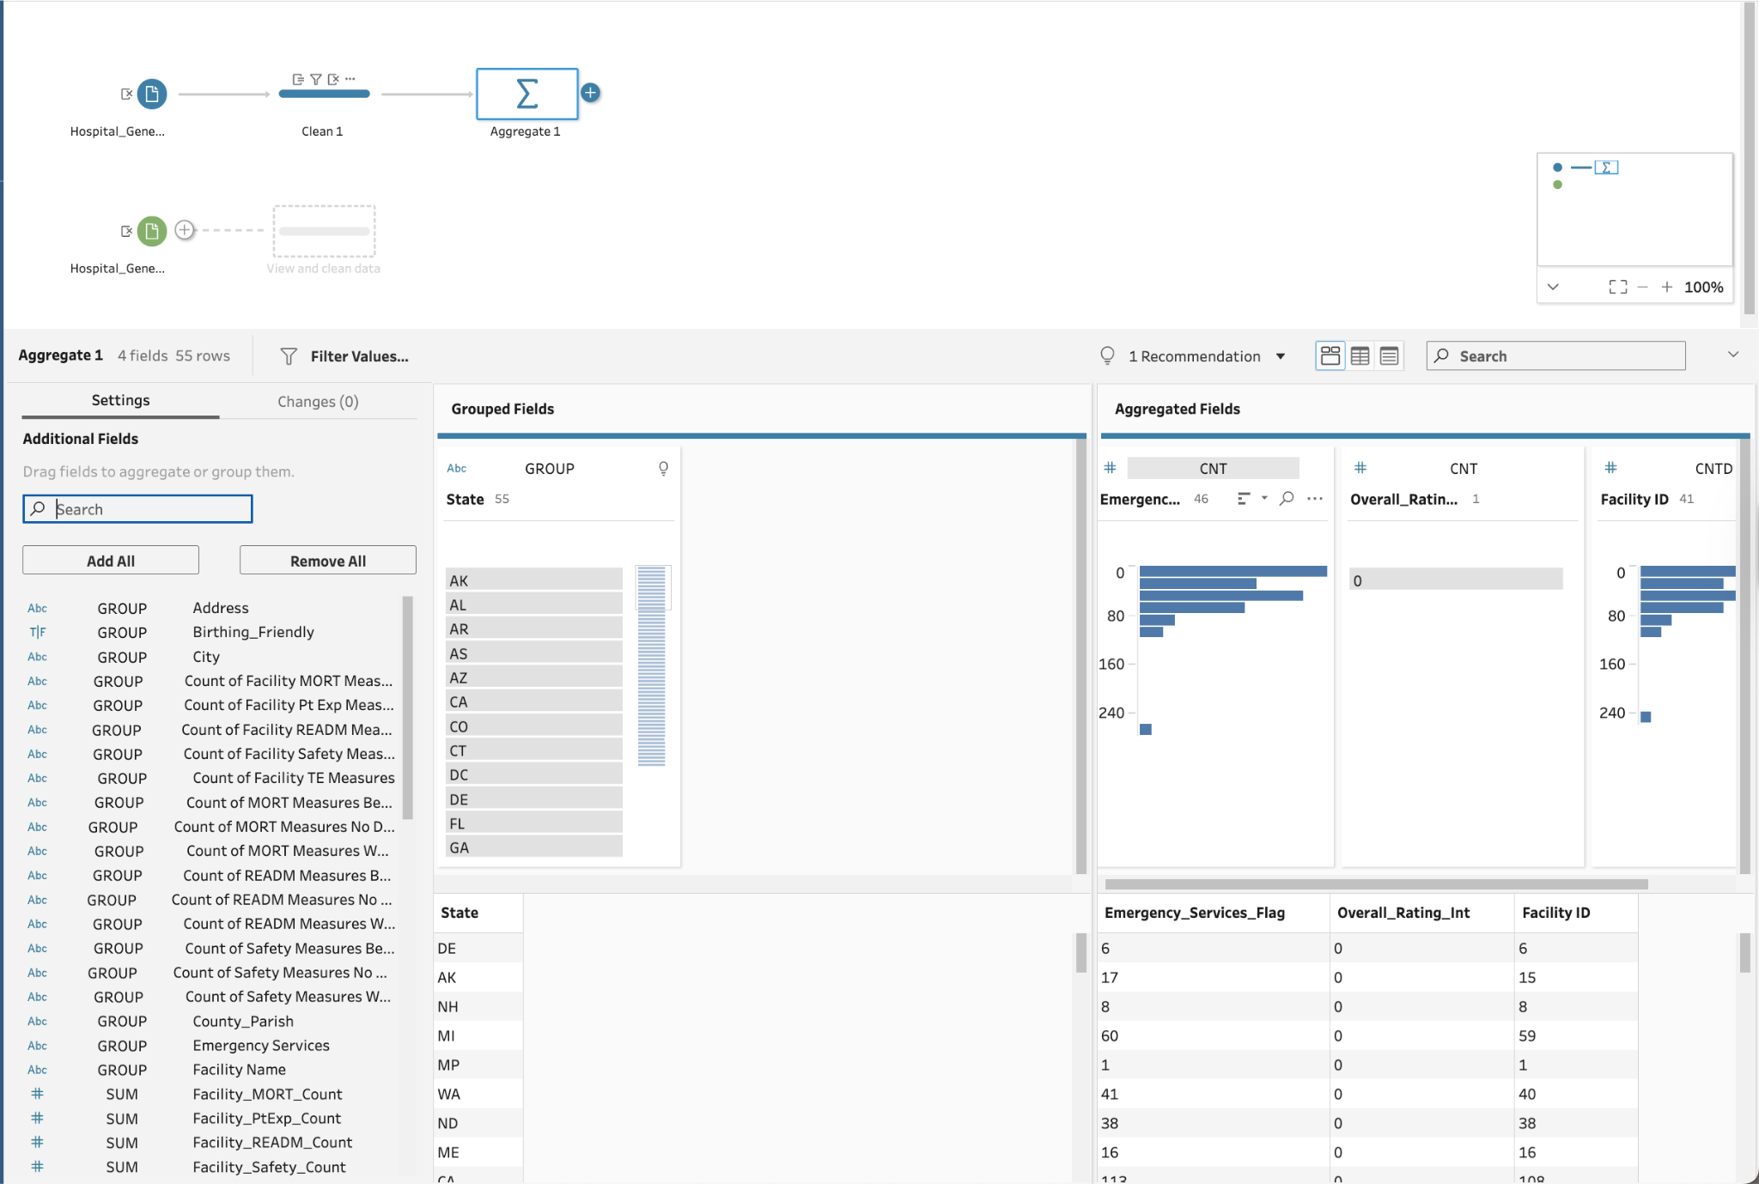

Step 9:
- I have annotated each step with short labels: Type fixes, Placeholder Null, and Derivations.
- Saved the file as hyper to run the flow with an informative name.
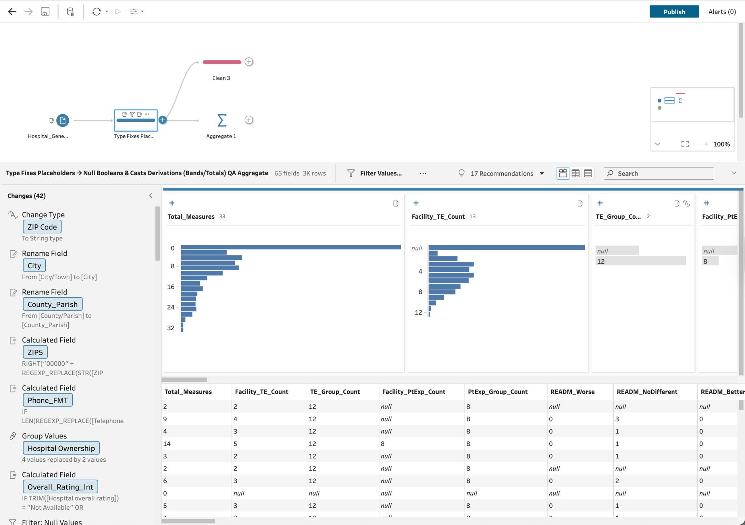
Step 10:
• I have added an Output step and wrote clean_hospital_general_information.hyper for use in visualisations.
• In the end opened in Tableau Desktop and renamed every worksheet with my last name.
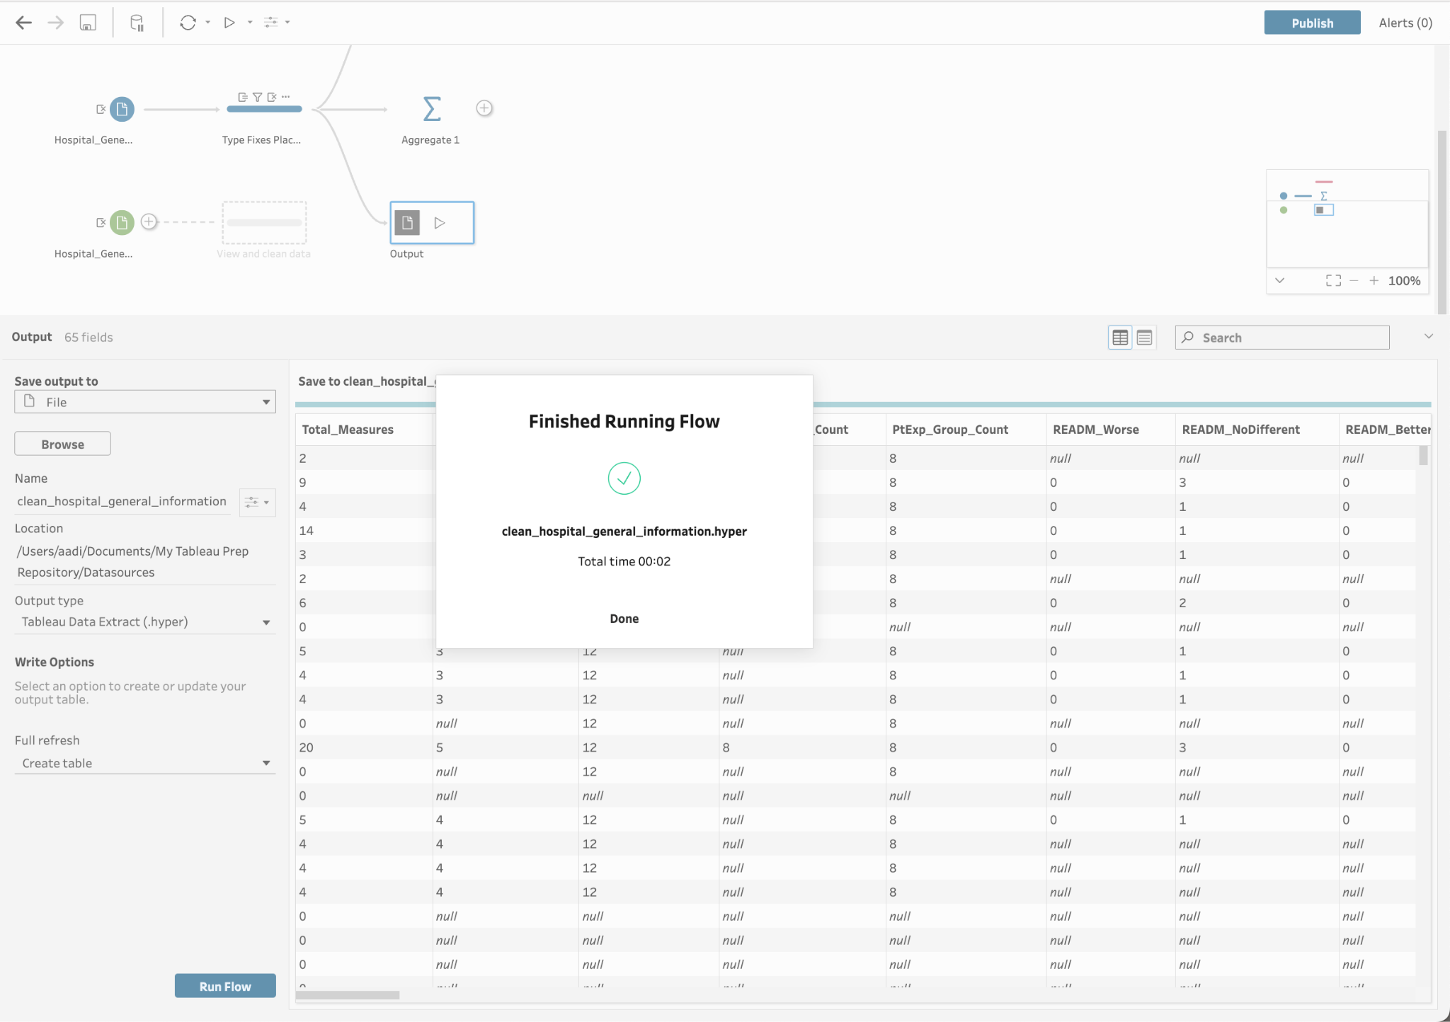

Part II: Why Data Visualisation?

1) The significance of visualising data
Data visualisation is a technology that helps make the right decisions. It helps convert raw, high-dimensional tables into the right visual structure, which aligns with the way human understands, enabling faster understanding and giving accurate patterns (Cleveland & McGill, 1984; Munzner, 2014).
Visualisation works in a shared language, it lets people with the right expertise, such as analysts, clinicians, and managers, understand together about the same concept without requiring everyone to learn a specific language (Knaflic, 2015; Cairo, 2019).
It improves both the speed and quality of the decisions (Few, 2012; Tufte, 2001). So, visualisation matters because it uses human visual cognition to understand the structural design, helps increase sense-making and action, and creates a typical understanding across stakeholders.

2) Why visualisation is important:

A) It helps leverage human perception to reveal the right format:
Psychophysical research shows that judgments are very accurate when it comes to the position and length of the data; they have degraded it with colour, 3D effects (Cleveland & McGill, 1984; Munzner, 2014). In my project, a boxplot of hospital overall ratings by hospital type exposes the medians, spreads and outliers. A histogram helps reveal the quality measures that tell a story about the performance of the data.

B) Examples in my area of interest:
- Hospital analytics (CMS Hospital General Information):
- Access:
  - To show: Map of % Emergency_Services_Flag by state; bar of top/bottom 10 states.
  - Why, because it directs resource planning and emergency preparedness.
- Quality performance:
  - To show: Boxplot of Overall_Rating_Int by Hospital Type; stacked bar of Rating_Band by Hospital Ownership.
  - Why, because it identifies structural differences by facility type/ownership.
- Reporting breadth:
  - To show: Histogram of Total_Measures; Pareto of “Measures Worse” categories.
  - Why, because it reveals participation gaps and the most consequential deficiencies.

- My Pediatric rehab/therapy operations:

- Waitlist & access:
  - Run the chart of referral-to-first-visit days with control limits, addressing staffing or policy changes.
- Utilisation & staffing:
  - Number of therapists utilisation by hour/day, remaining schedules.
- Outcomes & equity:
  - Complete plot of goal attainment by mixing cases or intake needs to detect therapists needing support.
- Revenue cycle clarity:
  - Numbers from billed - paid with denial categories; targeting the largest denial reasons.

C) It improves decision speed and quality for me:
While planning to see the access, a graph of the percentage of facilities with emergency services by state and community geography differences was available within 10 seconds, which helped me direct the outreach to specific regions.

D) It helps create shared understanding across different stakeholders:
Good visuals reduce misinformations between analysts, clinicians, and administrators (Knaflic, 2015).
In Conclusion, Visualisation is helpful because it helps simplify complexity into an understandable form, turning data into the right decisions. In healthcare analytics, where the managers are concerned with access, safety, experience, and cost, the right-designed visuals align with shared understanding and protect against misreading the data.

References:
- Cairo, A. (2019). How charts lie: Getting smarter about visual information. W. W. Norton & Company. https://wwnorton.com/books/9781324001560 W. W. Norton & Company
- Cleveland, W. S., & McGill, R. (1984). Graphical perception: Theory, experimentation, and application to the development of graphical methods. Journal of the American Statistical Association, 79(387), 531–554. https://doi.org/10.1080/01621459.1984.10478080 Taylor & Francis Online
- Knaflic, C. N. (2015). Storytelling with data: A data visualization guide for business professionals. Wiley. https://doi.org/10.1002/9781119055259 Wiley Online Library
- Munzner, T. (2014). Visualization analysis and design. A K Peters/CRC Press. https://doi.org/10.1201/b17511
- Few, S. (2012). Show me the numbers: Designing tables and graphs to enlighten (2nd ed.). Analytics Press. https://analyticspress.com/smtn.php analyticspress.com
- Tufte, E. R. (2001). The visual display of quantitative information (2nd ed.). Graphics Press. https://www.edwardtufte.com/book/the-visual-display-of-quantitative-information/

